**Session report 18/10/2022:**

*LABAUVIE – RAFFAELLI EVA*

*ROB3*

To begin with today’s session, I searched for the missing item’s links we needed to order all the components of our robot.

I found a better link for the battery, close of being the same that what we previously had, but on one of the recommended suppliers’ websites.

<https://fr.aliexpress.com/item/1005001873639818.html?spm=a2g0o.productlist.0.0.101a4895XnDAUy&algo_pvid=693a3804-a037-4b59-866a-055c321ef3cb&algo_exp_id=693a3804-a037-4b59-866a-055c321ef3cb-19&pdp_ext_f=%7B%22sku_id%22%3A%2212000017980682756%22%7D&pdp_npi=2%40dis%21EUR%2115.92%2111.14%21%21%214.61%21%21%402100bde716660751277306141ed8d0%2112000017980682756%21sea&curPageLogUid=gxQ3OL9ywzX8>

I had trouble finding a large enough belt, so I searched for a rubber caterpillar track belt because it can work for the conveyor.

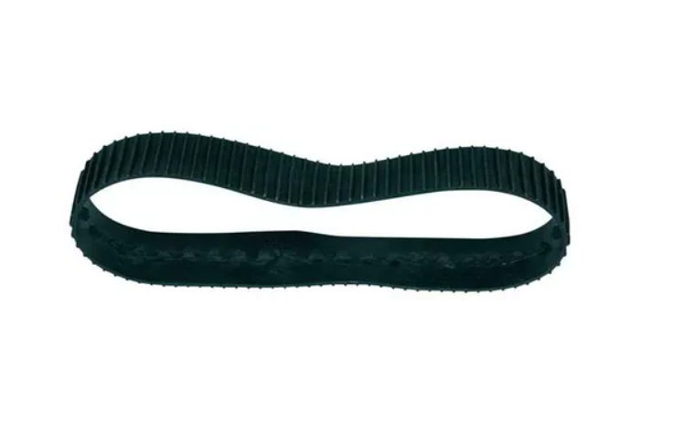

<https://www.aduis.fr/autres-accessoires-bande-en-caoutchouc-pour-chenille-art307091>

It still got a width that’s too small but if we put three next to each other it will work (and it’s cheaper than other belts) to get a conveyor around 10 cm of width.

I will edit the parameters of the modelling I’ve made the last session once we got the belts, it will be easier to measure and make sure it fits.

To go with this model, the rollers need to have grooves fitting the belt.

In the end, today’s researches weren’t really useful since we will wait to see which battery we will use, and we already have the required materials or the conveyor.

During the ordering of the components, we changed our strategy and took servomotors instead

I asked for servo motors to starts